**Project Design Phase-II**

**Solution Requirements (Functional & Non-functional)**

|  |  |
| --- | --- |
| Date | **09 November** |
| Team Id | PNT2022TMID07611 |
| Project Name | Inventory Management System for retailers. |
| Maximum Marks | 4 Marks |

**Functional Requirements:**

Following are the functional requirements of the proposed solution.

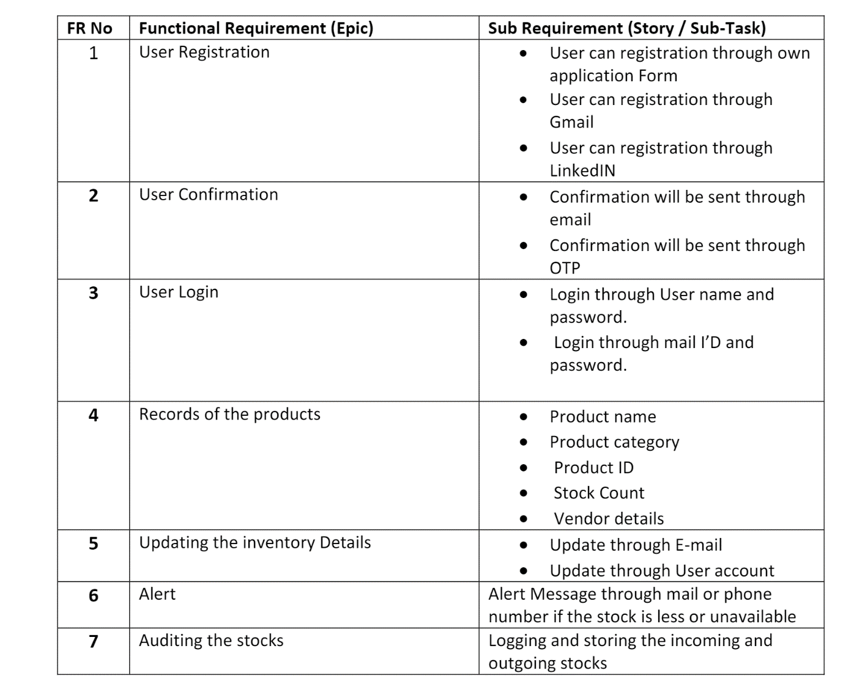

**Non-functional Requirements**:

Following are the non-functional requirements of the proposed solution

